MINISTRY OF EDUCATION OF
THE REPUBLIC OF BELARUS
EDUCATIONAL INSTITUTION
"MOGILEV STATE A.A. KULESHOV
UNIVERSITY"

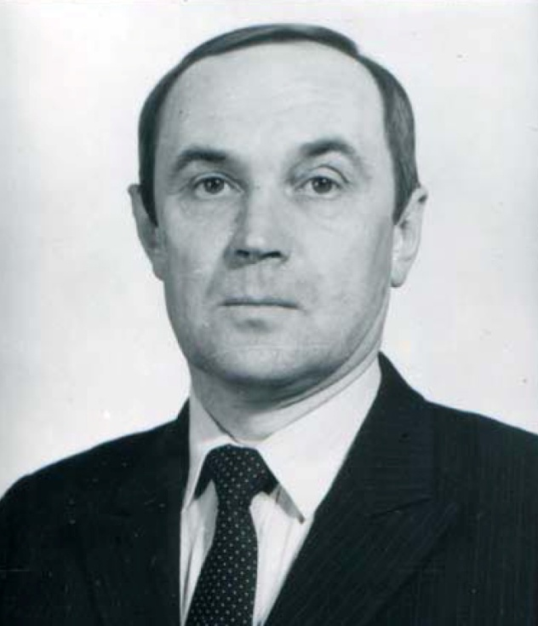

International Scientific and Practical Conference

KOPYTIN’S READINGS-4

March 19 - 20, 2020

Mogilev, 2020

Dear colleagues,
pupils, undergraduates, graduate students!

We invite you to take part in the international scientific and practical conference "Kopytin’s Readings-4", which will be held on March 19 - 20, 2020 in the educational institution "Mogilev State A. Kuleshov University."

Main topics to be discussed:

1. Problems of archeology, history, historiography of Belarus and adjacent territories.
2. Scientific, pedagogical and creative heritage of V.F. Kopytin.
3. Social structure, worldviews, communication of the population of Stone and Bronze age cultures in Central and Eastern Europe.
4. Ethno-cultural development, material culture, exchange and trade of the population of the Upper Dnieper with other regions of Central and Eastern Europe in the era of the early Iron Age and the Middle Ages.
5. Museum work, auxiliary historical disciplines and local history in the historical study. Protection of historical and cultural heritage.
6. Sources and methodology for studying the history of Belarus and adjacent territories.
7. Interdisciplinary studies of the history of society.
8. The problems of teaching history and social sciences in secondary and higher education.
9. “Dedicated to the Year of the Homeland ...” (creative works of secondary school students, lyceums, gymnasiums, essay presentations will be held at the conference section)

Working languages - Belarusian, Russian, Polish, Ukrainian, English

Following the conference, a collection of scientific articles will be published.

Conference fee and a copyright agreement are obligatory for publishing the article. The registration fee will be indicated in the invitation to the conference. Pupils of secondary schools, lyceums, gymnasiums may be exempt from paying the registration fee if they agree to receive the electronic version of the collection of articles. Student essays will be published on a competitive basis. Absentee participation in the conference is possible.

Conference participants are provided with a certificate of participation.

Contacts: (8022) 28-36-46 (department of archeology and special historical disciplines).

Coordinators:
Ageev Alexander Grigorievich - tel. +375447554519;
Kolosov Alexander Vladimirovich - tel. +375447163497;
Tkacheva Marina Valentinovna - tel. +375259532496;
Galinovskii Igor Vladimirovich - tel. +375296438022.

Е-mail: msu.kasid@gmail.com

Organizing Committee Address:
Republic of Belarus, 212022, Mogilev, Cosmonavtov Str., 1, room 405, Department of Archeology and Special Historical Disciplines

Submission Procedure

To participate in the conference, you should send:
• Application form for participation in the conference (form attached) by E-mail and regular mail;
• Materials by E-mail and one printed copy by regular mail.
• Texts of students' essays by E-mail and one printed copy by regular mail.
NB: Materials of students, undergraduates, graduate students are certified by the supervisor.
NB: Texts of essays of pupils are certified by the teacher (the project manager).
Deadline: February 25, 2020.

The organizing committee has the right to select submitted scientific reports and essays of pupils. Materials that are not relevant to the conference topics or are not prepared in accordance with the requirements are rejected. Authors are personally responsible for the information provided in the materials. The organizing committee does not provide information concerning the examination of individual works. Personal invitations to participate in the conference are sent after receiving the texts of reports, essays and their review.

Travel and other expenses are at the expense of the participants themselves.

Requirements for the publication of scientific materials

The materials of the report are presented in Belarusian, Russian, Polish, Ukrainian, English in the Word editor (version no lower than 6.0) for Windows in Times New Roman 14 font, all fields (upper, lower, left and right) are 2 cm each. Line spacing is 1. The name of the file should consist of the name and initials of the author.
The first line indicates the UDC index. Then, in center the title of the report is printed; through the interval surname(s) and initials of the author(s) are printed; the next line indicates the place of work or study; the next line indicates the city and country (in brackets). If necessary, scientific degree, academic status and a position of a supervisor is indicated.
Then goes summary of the article in Belarusian, Russian, Ukrainian, Polish, English with keywords (in accordance with the language of the article), summary in English with keywords. The volume of each summary is up to 500 characters with spaces, up to 7 keywords.
Further, the text of the report goes (paragraph indent is 1.25 cm). References to the literature are given in square brackets. Tables are inserted into the text. After the main text, a list of reference is given in alphabetical order (references are presented in accordance with the requirements of the Higher Attestation Commission of the Republic of Belarus). The volume of the text is up to 5 (five) full pages (including a list of references, illustrations (tif format 300 dpi), tables, diagrams, etc.).
Materials that do not meet the above mentioned requirements are not considered.

Design example:
UDC
TITLE OF THE REPORT
Ivanov I.I.
Educational Institution “Mogilev State A.A. Kuleshov University"
(Mogilev, Belarus)
Supervisor - Doctor of Historical Sciences, Professor V. Petrov
Summary
Keywords
……………………………………………………………………………………………………………………………………………………………………………[1, с. 24].
Literature:
- Мальдзіс, А. Як жылі нашы продкі ў XVIII стагоддзі / А. Мальдзіс. – Мінск : Лімарыус, 2001. – 384 с.

Requirements for publishing essays of pupils
Essays are submitted in Belarusian or Russian in the Word editor (version no lower than 6.0) for Windows at 1 interval in Times New Roman 14 font, all fields (upper, lower, left and right) should be 2 cm each. The file name should consist of a surname and initials of the author. The volume of the text is up to 3 (three) full pages.

Design example:

ESSAY TITLE
Sidorov A.M.
State Educational Institution “Secondary School No. 1 of Mogilev”, 10 “A” form
(Mogilev, Belarus)
The project manager is a history teacher P. Ivanov
……………………………………………………………………………………………………………………………………………………………………………

Application form of participant of the conference

Please include my report in the program of the international scientific-practical conference “Kopytin’s Readings-4”
Full Name
Title of the report or essay
Place of work or study (full name of the institution and its units)
Position
Academic degree
Academic status
Topic discussed (indicate the section number from the problem field)
Use of technical means (if so, indicate which)
Contact address (+ postal code)
Phone
E-mail
Form of participation (full-time / part-time)
Certificate of participation (yes / no)
For pupils - consent to receive an electronic version of the collection (yes / no)

If within three days after sending your application and scientific article to our email address, you will not receive a notification from the organizers of the conference, please send the letter again or contact the organizers of the conference by the telephone numbers indicated in the information letter.

